“MDCP Customer Access” PlayBook
EPR ID: 120482
Revised: Januray 17, 2012
Author: Slawomir Zachcial

Contents
Version Control 3
Chapter 1 – Overview 4
Section 1.1 – Application Architecture 4
Section 1.1.1 – Application Architecture 4
Section 1.1.2 – Application Architecture (Part 2) if applicable 6
Chapter 2 – Team & Vendor Elevation Process 6
Section 2.1 – Team Elevation 6
Section 2.2 – Vendor Elevation 7
Section 2.3 – Engage L3 Immediately for the Following 7
Chapter 3 – Incident & Escalation Management 7
Section 3.0 – Performance Expectations – not yet approved by Steve 7
Section 3.1 – Information Gathering 7
Section 3.2 – Application Event Monitoring (AEM) Triage 8
Section 3.3 – Monitoring & Recovery: Job Recovery Procedure (JRP) 10
Section 3.4 – Failover Steps 11
Section 3.5 – Health Check Steps 11
Section 3.5.1 – Application Availability Verification 11
Section 3.5.2 – Server AVailability Verification 12
Section 3.5.3 – Web Server Availability Verification 12
section 3.5.4 – Database Availability Verification 12
Section 3.6 – Known Issues With Known Workarounds/Resolutions 12
Section 3.6.1 – Down Recovery Known Issues 12
Section 3.6.2 – Data Timeliness Known Issues 12
Section 3.6.3 – Poor Performance Known Issues 12
Section 3.7 – Down Recovery Actions 12
Section 3.7.1 – Restarting an Application 13
section 3.7.2 – Backup and Restore Actions 13
Section 3.7.3 – Post Escalation Involvement 13
Section 3.8 – Data Timeliness 14
Section 3.9 – Poor Performance 14
Chapter 4 – Operations Management 14
Section 4.1 – Request Types 14
Section 4.1.1 – Request for Information 14
Chapter 5 – Change Management 14
Section 5.1 – How To Perform Changes 14

Version Control

Prepared by | Change | Date | Reviewed by | Date
abc | Create IT Playbook Template | 20100517 | Steve Blesi / Debbie Carr | 20100616
Slawek Zachcial | Created Playbook for MDCP Customer | 20120117 |  | 20120117

Chapter 1 – Overview
In all cases, we require a ticket to perform work. Clone the ticket the escalation manager is working from if needed and provide updates in the activity log documenting what you did. Remember to reflect the time you spent on an escalation in your time card.

Section 1.1 – Application Architecture

Section 1.1.1 – Application Architecture
The MDCP Customer Access application provides a set of remotely available services to read and write customer data managed by MDCP program. Those services are available through HTTP. Finders allow to retieve data and Elementary Processes allow to update the data.
The master document from which the following diagram originates is available at https://code1.corp.hp.com/svn/120482/trunk/mdcp/documentation/landscapes/120482-Infrastructure-Landscape.vsd

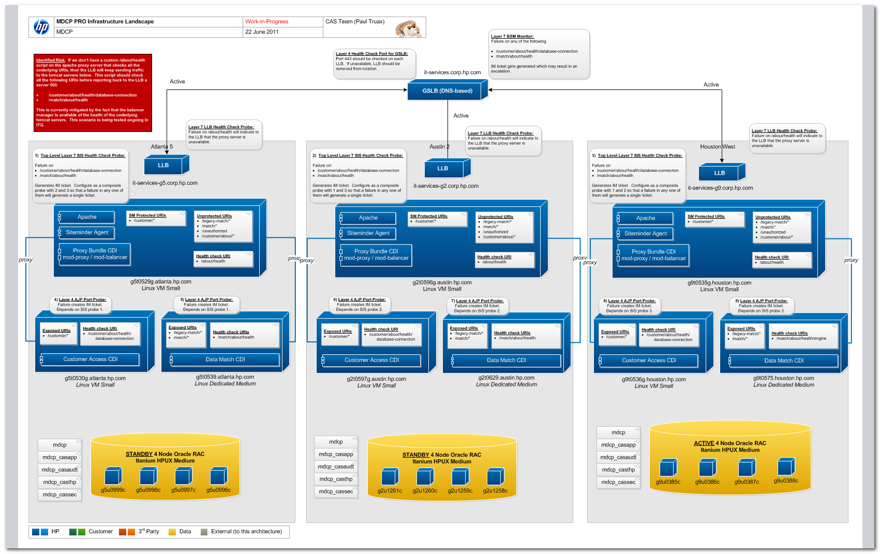

Section 1.1.2 – Application Architecture (Part 2) if applicable
Not applicable

Chapter 2 – Team & Vendor Elevation Process

Section 2.1 – Team Elevation
- At the 15 minute mark, engage with L3 engineering (OC is fine…) let them know you are participating in a formal escalation and that a warm handoff may be necessary.
  - Bring them in early if a failover is pending. Escalation managers are supposed to failover no later than the 30 minute mark.
- At the 30 minute mark, if service has not been restored hand the escalation off to L3.
- Please remember these are “guidelines” If you have completed your task(s) and are at a loss on what to do to next, hand off to L3 early. If they are using your access
MDCP Support Team Contact Information (NGDC):
Name | Value
HPSC Assignment Group | W-INCLV4-MDCP
L4 PDL | USERS-CAS-DEV@groups.hp.com
Customer Support Manager | TBD
OC Support Manager | TBD
MDCP Contact List | Slawomir Zachcial (+33 476.145.044)  Anu Sahani or Liz Christensen ???  Santhosh Chandan (281-546-0721)

Section 2.2 – Vendor Elevation
Not applicable.

Section 2.3 – Engage L3 Immediately for the Following
- List criteria for engaging L3 immediately.

Chapter 3 – Incident & Escalation Management

Section 3.0 – Performance Expectations – not yet approved by Steve
- Join the escalation call immediately.
- Join the virtual classroom, with name and function.
- Go on mute when not talking.
- Keep an eye on the clock – elevate consistently.
- Avoid side discussions and maintain a professional demeanor.
- Use the chat room for additional information.

Section 3.1 – Information Gathering
- HPIT Escalation Number
- Server(s) impacted (obtain cluster information if necessary)
- Application(s) impacted
- Database(s) impacted
- Server Environment (i.e. NGDC, RCS, Austin Purgatory, New Legacy)
- Check history of CI.
- Obtain a ticket to document your work to If you need to clone the ticket provide the ticket to the escalation manager.
- Run the configuration log collector on the affected server.
- If an analyst is unsure of the solution, communication with peers is encouraged as a first step. Someone else may have seen this issue.
- Web searches for solutions sometime yield results.

Section 3.2 – Application Event Monitoring (AEM) Triage
There are 3 types of URLs that can be used for testing:
- ReST web service URL – checks the application stack by performing a sample ReST web service invocation. The invocation return JSON document. Requests going through web servers require that the user performing the check must be authenticated to @hp SiteMinder at http://athp.hp.com/.
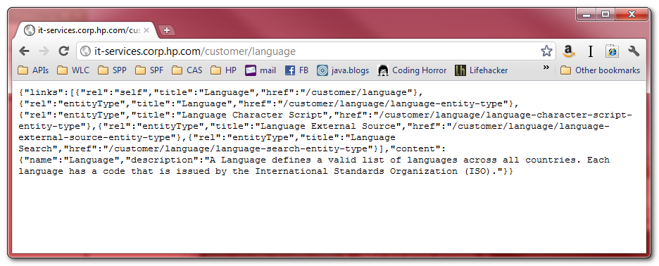
- Proxy Server HTML page – checks whether the web server is running
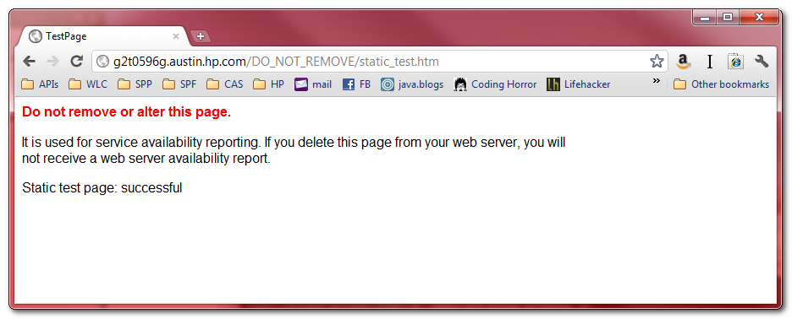
- Database healthcheck URL – checks the connectivity to the database from the application server on which it is executed. Upon successful execution the URL returns “HTTP 204” (usually empty page in the browser), and if an error occurs the error page is returned.
Name | Value
GSLB ReST URL; check to determine if there is a customer impact.  Requires @hp authentication. | http://it-services.corp.hp.com/customer/language
Austin 2 LLB Test URL  Requires @hp authentication. | http://it-services-g2.austin.hp.com/customer/language
Austin 2 Proxy Server Test URL  Requires @hp authentication. | http://g2t0596g.austin.hp.com/customer/language
Austin 2 Proxy Server HTML page | http://g2t0596g.austin.hp.com/DO_NOT_REMOVE/static_test.htm
Austin 2 Application Server Test URL; check first to validate application is available | http://g2t0597g.austin.hp.com:25780/customer/language
Atlanta 5 LLB Test URL  Requires @hp authentication. | http://it-services-g5.atlanta.hp.com/customer/language
Atlanta 5 Proxy Server Test URL  Requires @hp authentication. | http://g5t0529g.atlanta.hp.com/customer/language
Atlanta 5 Proxy Server HTML page | http://g5t0529g.atlanta.hp.com/DO_NOT_REMOVE/static_test.htm
Atlanta 5 Application Server Test URL; check first to validate application is available | http://g5t0530g.atlanta.hp.com:25780/customer/language
Houston 9 LLB Test URL  Requires @hp authentication. | http://it-services-g9.houston.hp.com/customer/language
Houston 9 Proxy Server Test URL  Requires @hp authentication. | http://g9t0535g.houston.hp.com/customer/language
Houston 9 Proxy Server HTML page | http://g9t0535g.houston.hp.com/DO_NOT_REMOVE/static_test.htm
Houston 9 Application Server Test URL; check first to validate application is available | http://g9t0536g.houston.hp.com:25780/customer/language
Austin 2 Database healthcheck URL | http://g2t0597g.austin.hp.com:25780/customer/about/health/database-connection
Atlanta 5 Database healthcheck URL | http://g5t0530g.atlanta.hp.com:25780/customer/about/health/database-connection
Houston 9 Database healthcheck URL | http://g9t0536g.houston.hp.com:25780/customer/about/health/database-connection

Section 3.3 – Monitoring & Recovery: Job Recovery Procedure (JRP)
There are only a couple components that could be problematic in this initial release of MDCP.
- Web Proxies Down (g2t0596g.austing.hp.com, g5t0529g.atlanta.hp.com or g9t0535g.houston.hp.com)
  - These 3 servers are basic dedicated web hosting servers running RH5 64-bit, with nothing but a proxy AJP configuration in the following location (/opt/casfw/proxy-bundle/etc/conf.d)
  - Contact (OV ICC) Command Center and have them get web hosting support to restart the apache server(s)
    - Login to server
    - pbrun bash
    - sudo su - casfw
    - run ./opt/webhost/dweng/bin/restart_apache -all
    - Validate that webserver is operational by hitting the following URL:
      - http://g2t0596g.austin.hp.com/DO_NOT_REMOVE/static_test.htm
      - http://g5t0529g.atlanta.hp.com/DO_NOT_REMOVE/static_test.htm
      - http://g9t0535g.houston.hp.com/DO_NOT_REMOVE/static_test.htm
- MDCP Customer Access Application Server(s) down (g2t0597g.austin.hp.com, g5t0530g.atlanta.hp.com or g9t0536g.atlanta.hp.com)
  - These 3 servers are basic dedicated web hosting servers running RH5 64-bit. The MDCP Customer Access application is running there along other MDCP services such as Address Doctor.
  - Contact (OV ICC) Command Center to have them restart address doctor server
    - Login to server
    - pbrun bash
    - sudo su - casfw
    - cd /opt/casfw/customer-access-NNN
    - cd bin
    - ./tomcat-customer-access.sh start
    - Verify if it is running ps -ef|grep customer-access
It should look like
casfw 470 1 0 2011 ? 00:12:47 /opt/casfw/customer-access-2011.10-M1/software/oracle-java-1.6.0_24/java -Djava.util.logging.config.file=/opt/casfw/customer-access-2011.10-M1/etc/tomcat-customer-access/conf/logging.prties -Djava.util.logging.manager=org.apache.juli.ClassLoaderLogManager -Djava.awt.headless=true -Djavax.net.ssl.truore=/opt/casfw/customer-access-2011.10-M1/etc/security/java6_cacerts -Xmx512m -Djava.endorsed.dirs=/opt/casfw/customccess-2011.10-M1/software/apache-tomcat-6.0.32/endorsed -classpath /opt/casfw/customer-access-2011.10-M1/software/ap-tomcat-6.0.32/bin/bootstrap.jar -Dcatalina.base=/opt/casfw/customer-access-2011.10-M1/etc/tomcat-customer-access -Dlina.home=/opt/casfw/customer-access-2011.10-M1/software/apache-tomcat-6.0.32 -Djava.io.tmpdir=/opt/casfw/customer-as-2011.10-M1/etc/tomcat-customer-access/temp org.apache.catalina.startup.Bootstrap start
    - Verify that the application is running by hitting the following URLs (you will need to authenticate at http://athp/hp.com/ first):
      - http://g2t0597g.austin.hp.com:25780/customer/language
      - http://g5t0530g.atlanta.hp.com:25780/customer/language
      - http://g9t0536g.houston.hp.com:25780/customer/language
- On failure of any of the above components, tickets will be generated against the MDCP AG.

Section 3.4 – Failover Steps

No failover steps necessary. Managed by GSLB and LLB.

Section 3.5 – Health Check Steps
Perform a health check consisting of the following checks:

Section 3.5.1 – Application Availability Verification
- Please see above table for application availability verification routines

Section 3.5.2 – Server AVailability Verification
- ping g2t0597g.austin.hp.com
- ping g5t0530g.atlanta.hp.com
- ping g9t0536g.houston.hp.com
- ping g2t0596g.austin.hp.com
- ping g5t0529g.atlanta.hp.com
- ping g9t0535g.houston.hp.com
- After failing these basic connection attempts, engage Linux platform team. Let them know that the server is down and the connection attempts you have made.

Section 3.5.3 – Web Server Availability Verification
- See section 3.3

section 3.5.4 – Database Availability Verification
No database in solution

Section 3.6 – Known Issues With Known Workarounds/Resolutions
Following are workarounds for known issues.

Section 3.6.1 – Down Recovery Known Issues
Insert known issue and resolution.

Section 3.6.2 – Data Timeliness Known Issues
Insert known issue and resolution.

Section 3.6.3 – Poor Performance Known Issues
Insert known issue and resolution.

Section 3.7 – Down Recovery Actions

Section 3.7.1 – Restarting an Application
See section 3.3 for steps.

section 3.7.2 – Backup and Restore Actions
Engage L4 application team. Restoration involves the following steps.
- Start with standard dedicated web hosting
- Install the appropriate version of customer-access application on the application servers. You can get CDI from http://repo1.corp.hp.com/nexus/index.html#nexus-search;customer-access-installer.
- Only if needed install proxy-bundle on the web servers. You can get CDI from http://repo1.corp.hp.com/nexus/index.html#nexus-search;proxy-bundle-installer.
IMPORTANT: these proxy servers are shared with other MDCP applications therefore re-installing proxy-bundle will impact other applications.
- Include in the DWH apache configuration (HTTP and SSL) configuration files available in /opt/casfw/proxy-bundle/etc/conf.d/* to point to MDCP applications runtime
- Start processes

Section 3.7.3 – Post Escalation Involvement
After involvement in an escalation, it is vital that management is informed of what issues were discovered and what actions were taken to resolve these issues. Also, if any changes were made to the backup environment in order to resolve any issues, the backup team member is responsible to restore the environment to its previous state (i.e. migrate clients back to their correct cell server, remove dummy backups, etc.).
Summary checklist
Escalations can be a high pressure situation because of the impact a down application/server can have on HP. In an escalation, it is important to stay calm and make rational decisions. The following checklist should guide you in the event of an escalation.
- Be available in the ITOC virtual room and join any escalation event rooms/conference calls if requested.
- Contact Kenneth Brown if the business continuity is dependent of backup team tasks or if a higher level of support is required.
- Gather information pertaining to the issues in order to perform backup/restore related activities and make a recommendation to get business continuality restored.
- In the case or a restore, ensure that all media needed is available. The general rule of thumb is that you request all media from the full backup session and every subsequent incremental backup session. If the media is not available, make needed request to the media team.
- Perform required tasks.
- Continue to communicate with escalation event room/conference call if necessary, notify with backup/restore tasks are complete, and ensure that data was validated.
- Track restores if one was performed.
- Update management post escalation and restore backup environment to its previous state.

Section 3.8 – Data Timeliness
Insert Data Timeliness instructions

Section 3.9 – Poor Performance
Insert Poor Performance instructions

Chapter 4 – Operations Management

Section 4.1 – Request Types

Section 4.1.1 – Request for Information
Requests are generally information or service related to general care and feeding …….
- How do I…..(i.e phone, ip address, bulk accounts, bulk ip addresses)
- Service request to run report
- L1 and L2 support – more detail than Incident Mgmt
- Provisioning (include specific SOX compliance requirements)
- Capacity
- Reset Tidal master
- SLA metrics (if applicable)
- SOX compliance

Chapter 5 – Change Management

Section 5.1 – How To Perform Changes

- Basic repetitive changes (i.e. add space, user ids)

